# Streaming MP3 files in Opensim

 MP3 files can be used to make region and parcel-wide background sounds.

The files are in Outworldzfiles\Apache\htdocs\Audio.  You can add your own audio files there.

This selection of background sounds is CC-0 so can be used anywhere with no license restrictions.

You can play one sound at a time per parcel using your DreamGrid Apache web server. Apache must be enabled and running for this to work.  You can divide up your land into small parcels and play different audio sounds in each parcel

* Oceans
* Forests
* Snow
* Rivers Caves
* and Streams
* Waterfalls

How does it work?  It plays on a sim-wide on a special image.

These are the steps to play MP3 files continually on your region or parcel.

1.  In your viewer, go to the About Land Menu:

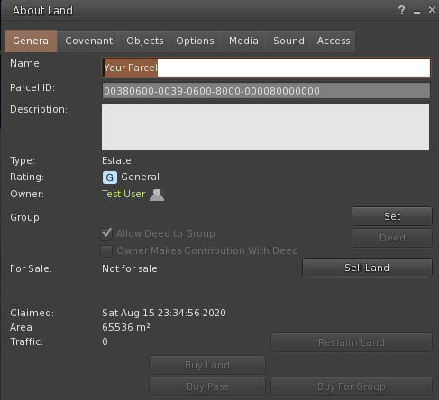

2. Change to the Media Tab:  
  
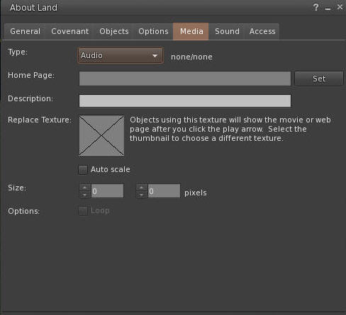  
  
3. Click the Set button and enter the URL of the desired sound.  You can click the link, and copy and paste the path.  
  
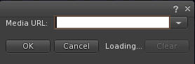  
  
4. You need a unique texture not used before. This PNG file works well. Right click and save it, and then upload it to your viewer.  
  
  
  
Drag and drop the Audio.png file into the X window so it appears like this.  You need to use the web URL for your grid, typically [http://something.outworldz.net:80/Audio](http://something.outworldz.net/Audio), where ‘something’ is your chosen URL. You can get this link in the Help menu in the fist selection. Then change the port to whatever port you use for Apache, in Settings->Apache.  
  
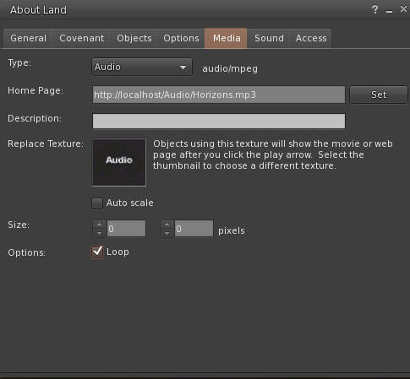  
  
Make a prim or find a hidden face on a prim. Click "Select Face". Choose one face only!  Drag and drop the image onto one face.

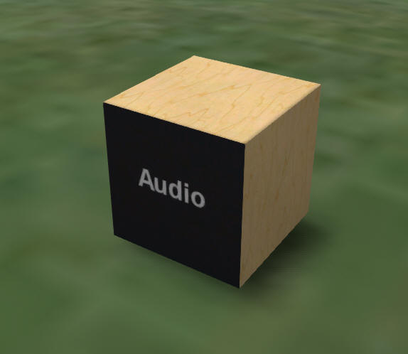  
  
Now click the movie camera at the top right of your viewer:  
  
  
  
  
Enjoy your new background sound!